Indian Census SQL Queries & Results

1. top 5 states in terms of voter turnout ratio for 2014 and 2019

select top 5 state,(sum(total_votes)/sum(distinct total_electors))*100 as voter_turnout_ratio from results1

group by state

order by voter_turnout_ratio desc

select top 5 state,(sum(total_votes)/sum(distinct total_electors))*100 as voter_turnout_ratio from results2

group by state

order by voter_turnout_ratio desc

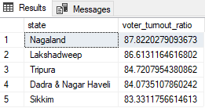 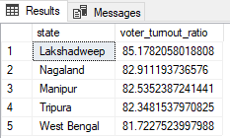

1. bottom 5 states in terms of voter turnout ratio for 2014 and 2019

select top 5 state,(sum(total_votes)/sum(distinct total_electors))*100 as voter_turnout_ratio from results1

group by state

order by voter_turnout_ratio

select top 5 state,(sum(total_votes)/sum(distinct total_electors))*100 as voter_turnout_ratio from results2

group by state

order by voter_turnout_ratio

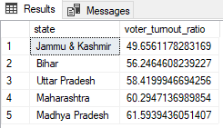 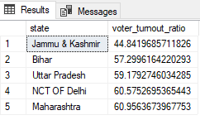

1. top 5 constituencies in terms of voter turnout ratio for 2014 and 2019

select top 5 pc_name,state,(sum(total_votes)/sum(distinct total_electors))*100 as voter_turnout_ratio from results1

group by pc_name,state

order by voter_turnout_ratio desc

select top 5 pc_name,state,(sum(total_votes)/sum(distinct total_electors))*100 as voter_turnout_ratio from results2

group by pc_name,state

order by voter_turnout_ratio desc

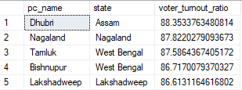 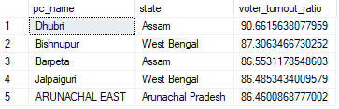

1. bottom 5 constituencies in terms of voter turnout ratio for 2014 and 2019

select top 5 pc_name,state,(sum(total_votes)/sum(distinct total_electors))*100 as voter_turnout_ratio from results1

group by pc_name,state

order by voter_turnout_ratio desc

select top 5 pc_name,state,(sum(total_votes)/sum(distinct total_electors))*100 as voter_turnout_ratio from results2

group by pc_name,state

order by voter_turnout_ratio desc

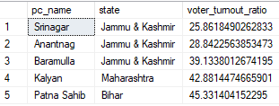 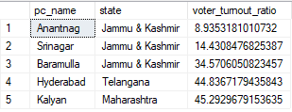

1. constituency which voted the most for NOTA

select top 5 pc_name,sum(total_votes) votes from Appended

where party = 'NOTA'and year=2014

group by pc_name

order by votes desc

select top 5 pc_name,sum(total_votes) votes from Appended

where party = 'NOTA'and year=2019

group by pc_name

order by votes desc

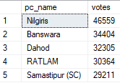 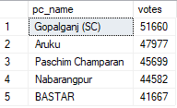

1. constituencies voting for same parties for both years

select top 5 t1.pc_name,t1.party,t2.ratio-t1.ratio as ratio_diff from

(select * from

(select *,dense_rank() over(partition by pc_name order by ratio desc) rnk from

(select pc_name,party,year,(total_votes/total_electors)*100 ratio from results1)a)b

where rnk=1) t1

join

(select * from

(select *,dense_rank() over(partition by pc_name order by ratio desc) rnk from

(select pc_name,party,year,(total_votes/total_electors)*100 ratio from results2)a)b

where rnk=1) t2

on t1.pc_name = t2.pc_name and t1.year != t2.year

where t1.party = t2.party

order by ratio_diff desc

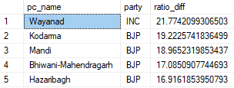

1. constituencies voting for different parties for both years

select top 5 t1.pc_name,t1.party,t2.ratio-t1.ratio as ratio_diff from

(select * from

(select *,dense_rank() over(partition by pc_name order by ratio desc) rnk from

(select pc_name,party,year,(total_votes/total_electors)*100 ratio from results1)a)b

where rnk=1) t1

join

(select * from

(select *,dense_rank() over(partition by pc_name order by ratio desc) rnk from

(select pc_name,party,year,(total_votes/total_electors)*100 ratio from results2)a)b

where rnk=1) t2

on t1.pc_name = t2.pc_name and t1.year != t2.year

where t1.party !=t2.party

order by ratio_diff desc

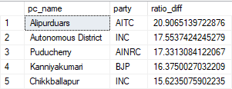

1. Top constituencies for two major parties where they have gained vote share in 2019 compared to 2014

select top 5 t1.pc_name,t1.party,t1.votes-t2.votes vote_diff from

(select pc_name,party,(sum(total_votes)/sum(distinct total_electors))*100 votes from Appended

where party = 'BJP' and year=2019

group by party,pc_name) t1

join

(select pc_name,party,(sum(total_votes)/sum(distinct total_electors))*100 votes from Appended

where party = 'BJP' and year=2014

group by party,pc_name) t2 on t1.pc_name=t2.pc_name

where t1.votes>t2.votes

order by vote_diff desc

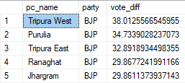

select top 5 t1.pc_name,t1.party,t1.votes-t2.votes vote_diff from

(select pc_name,party,(sum(total_votes)/sum(distinct total_electors))*100 votes from Appended

where party = 'INC' and year=2019

group by party,pc_name) t1

join

(select pc_name,party,(sum(total_votes)/sum(distinct total_electors))*100 votes from Appended

where party = 'INC' and year=2014

group by party,pc_name) t2 on t1.pc_name=t2.pc_name

where t1.votes>t2.votes

order by vote_diff desc

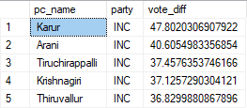

1. Top constituencies for two major parties where they have lost vote share in 2019 compared to 2014

select top 5 t1.pc_name,t1.party,t2.votes-t1.votes vote_diff from

(select pc_name,party,(sum(total_votes)/sum(distinct total_electors))*100 votes from Appended

where party = 'BJP' and year=2019

group by party,pc_name) t1

join

(select pc_name,party,(sum(total_votes)/sum(distinct total_electors))*100 votes from Appended

where party = 'BJP' and year=2014

group by party,pc_name) t2 on t1.pc_name=t2.pc_name

where t1.votes<t2.votes

order by vote_diff desc

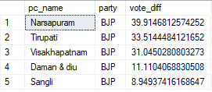

select top 5 t1.pc_name,t1.party,t2.votes-t1.votes vote_diff from

(select pc_name,party,(sum(total_votes)/sum(distinct total_electors))*100 votes from Appended

where party = 'INC' and year=2019

group by party,pc_name) t1

join

(select pc_name,party,(sum(total_votes)/sum(distinct total_electors))*100 votes from Appended

where party = 'INC' and year=2014

group by party,pc_name) t2 on t1.pc_name=t2.pc_name

where t1.votes<t2.votes

order by vote_diff desc

